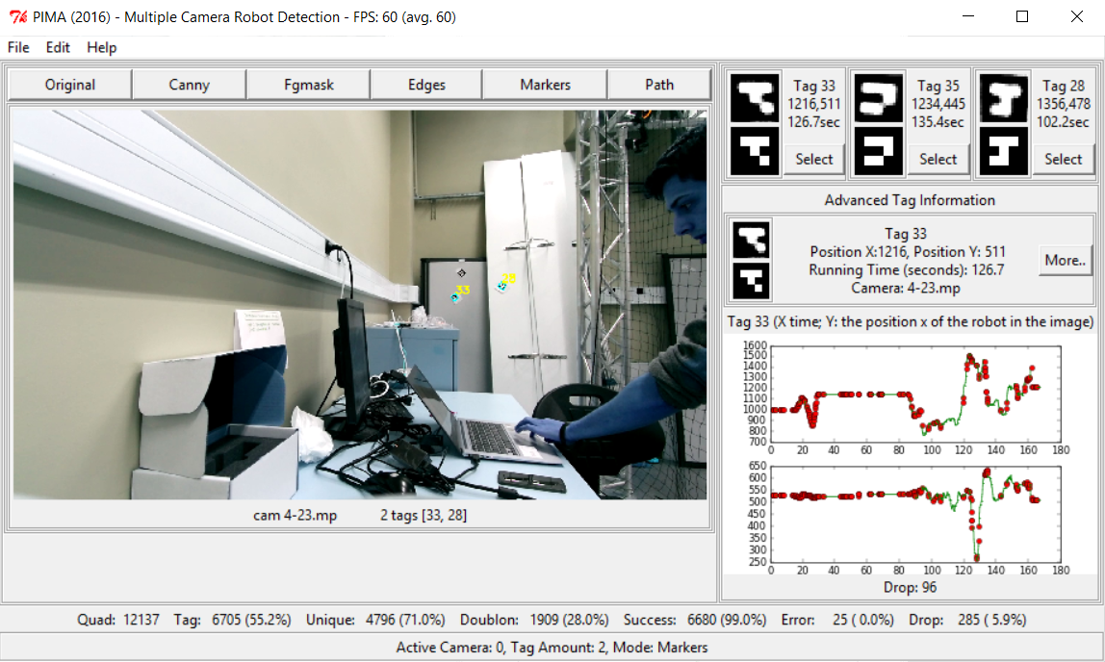

(-) epsilon = 0.035*cv2.arcLength(edges[i], True)  
(+) epsilon = 0.025*cv2.arcLength(edges[i], True)

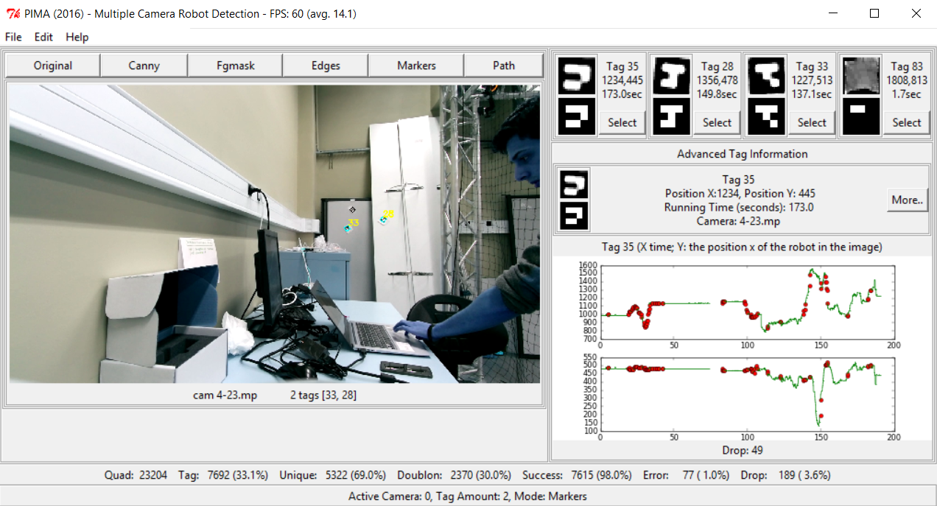

(-) mat = cv2.GaussianBlur(mat, (5,5), 0)

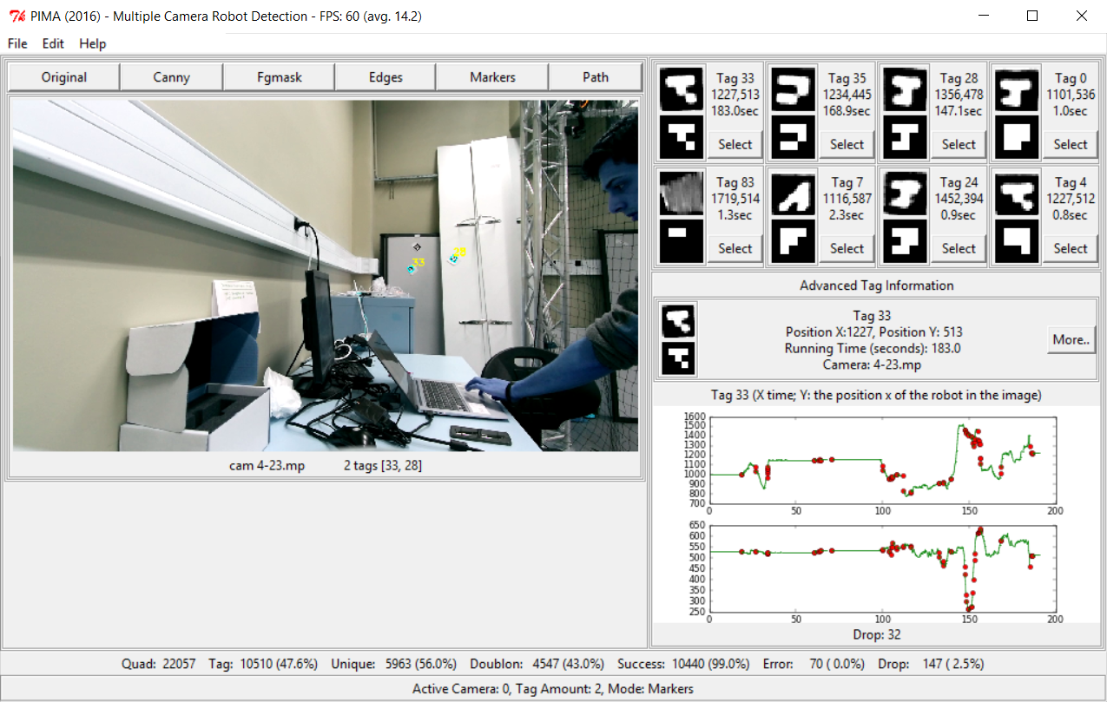

(+) mat = cv2.GaussianBlur(mat, (3,3), 0)  
(-) epsilon = 0.025*cv2.arcLength(edges[i], True)  
(+) epsilon = 0.035*cv2.arcLength(edges[i], True) 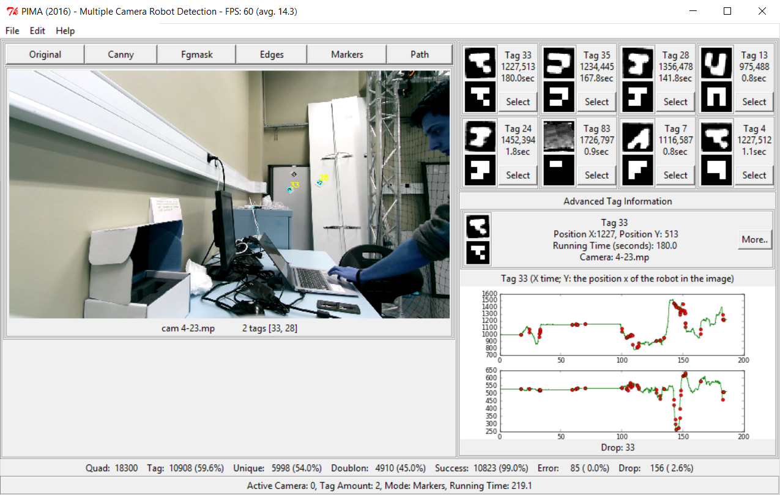

(-) epsilon = 0.035*cv2.arcLength(edges[i], True)  
(+) epsilon = 0.060*cv2.arcLength(edges[i], True)

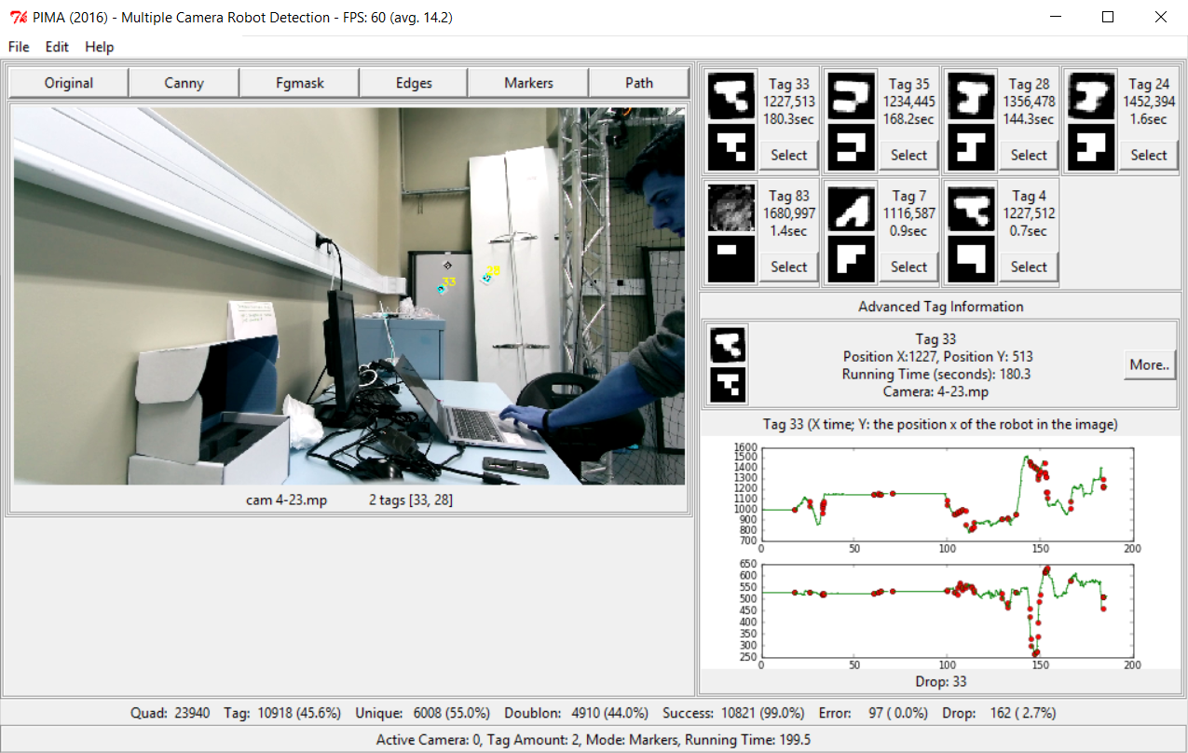

(-) epsilon = 0.060*cv2.arcLength(edges[i], True)  
(+) epsilon = 0.100*cv2.arcLength(edges[i], True)

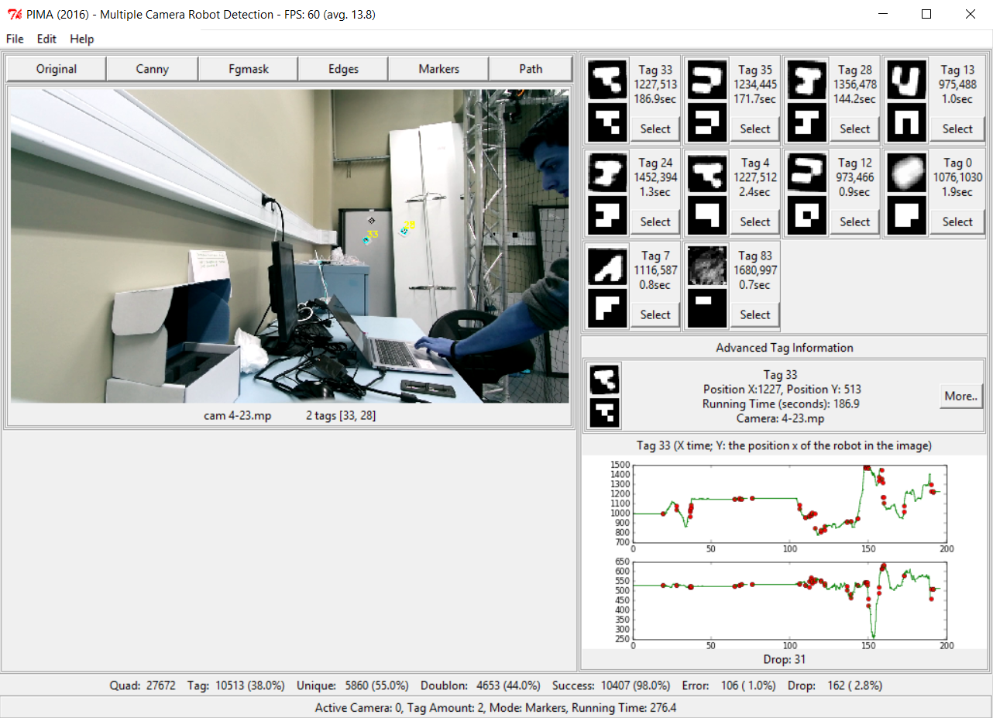

cv2.contourArea(approx_curve) (-) < 100, > 1000 (+) < 50, > 800  
MAX_DISTANCE (-) * 0.090 (+) * 0.095

